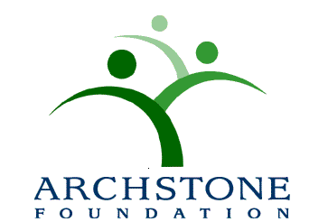

Nomination Application for the
Archstone Foundation Award for Excellence in Program Innovation
Cover Sheet

Nominator Name: Title:
Organization¹:
Address Line 1:
Address Line 2:
City: State: Zip:

Contact Telephone: ( ) - E-mail: @ .

How did you hear about the award?

Contact Information for the program being nominated:

Name of Organization:
Address Line 1:
Address Line 2:
City: State: Zip:
Telephone: ( ) - Fax: ( ) -

Primary Contact Person: Title:
Contact Telephone: ( ) - E-mail: @ .

Program Title:

Before starting your application process, please answer the following questions:
- Has the nominated program been around for more than 10 years?
- Has the nominated program received any other national awards or recognition in the past 5 years?
- If you answered “YES” to either one of the questions above, your program does not qualify for the award.

Check List: The following information must be included in your application: (Maximum six single-space typed pages)

- Description of the public health problem being addressed*:

- Description of the population served² including:
- How does the program benefit adults 65 and older?
- Does it serve low-income and/or ethnically diverse adults 65 and older?

- Description of the program design and rationale to include the following*:
- What makes this program unique or special?
- How does the program address unmet public health need?
- Does it build upon research? If so, how?
- Have similar projects been done before?
- Is it a replication of an already established program?
- How was the project planned and implemented?
- Is this an evidence-based program?

- Statement of the program’s goals and objectives:

- Description of partnerships / collaborations:
- How does the program include local, statewide, and/or national partners such as community-based organizations, the aging service network, government departments (e.g. public health, healthcare, human services) and/or others?

- List of committed resources from your organization and your partners:

- Achievements to date include:
- Measurable program outcomes, benefits, and public health impact. Please include any quantitative and qualitative evidence to support your statements.
- The scope or scale of the program with respect to systems change.
- Number of older adults impacted.

- Replication strategies include*:
- Could this program be duplicated?
- What are the challenges in duplicating this program?
- Describe any lessons learned that can serve as a guide for others attempting to achieve a similar goal.

- Dissemination strategy and activities to date:
- Do you have a broad plan (local, state, or national and stakeholders) for dissemination? If so, please describe and include your progress to date.
- If not, please describe your plan for sharing or disseminating information about your program to date.

¹ Eligible organization should be US-based and hold not-for-profit status
² Eligible program should target and show significant impact for 65 and older adults population
* Please note that these sections will be weighted more heavily by reviewers.

