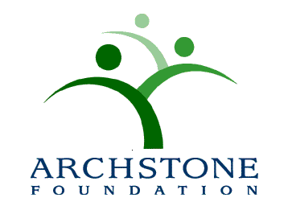

2017 Archstone Award for Excellence in Program Innovation

Call for Nominations

Join us in Atlanta!

As of November 2, 2016, the Aging & Public Health Section of the American Public Health Association will accept nominations for the 2017 Archstone Award for Excellence in Program Innovation. The award was established in 1997 to identify best practice models in the field of health and aging, and to provide recognition and an opportunity to highlight the work at the annual meetings of the American Public Health Association.

Programs that effectively link academic theory to applied practice in the field of public health and aging are eligible for nomination. Nominees should also have documented results, but have been in operation less than 10 years. Preference will be given to nominees who have not received prior awards or special recognition.

An independent panel will review all nominations. The criteria for award selection will include:
- Creativity in project design;
- Documented outcomes and benefits of the program;
- Replication potential;
- Evidence of collaboration and partnerships; and
- Dissemination strategy.

The winner is expected to attend the 145th Annual Meeting of the American Public Health Association in Atlanta, Georgia, November 4 – 8, 2017, at a special Aging & Public Health Section Award Session and attend the awards ceremony. In recognition of this achievement, and to assist with the travel expenses, the winning organization will receive a $500 cash award. Honorable mention(s) may also be awarded to one or more nominees submitting distinguished programs as determined by the review panel.

To Apply:

- Complete the Application Cover Sheet included; and

- Include two single-space typed-pages that describe the program to be nominated. The narrative should include the: a) problem being addressed; b) description of the population served; c) project’s design and rationale; d) statement of program’s goals and objectives; e) description of partnerships or collaboration; e) list of committed resources/funding; f) achievements to date, specifically, measurable benefits and outcomes; g) replication strategy; and h) dissemination strategies of the activities to date.

Only one program may be nominated per agency or organization. Nominations are to be emailed by March 31, 2017 to:

Irena Pesis-Katz, Ph.D.
Chair, Archstone Foundation Awards Committee
Senior Director, PHM Informatics and Payment Innovation
Associate Professor, Clinical Nursing and Public Health Sciences

Phone: (585) 758-0022
Email: Irena.PK@urmc.rochester.edu

Application information and a list of past winners may also be found at www.archstone.org.

