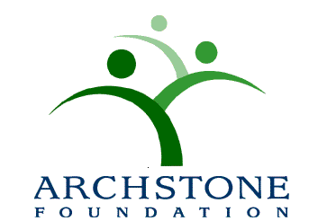

Nomination Application for the
2017 Archstone Foundation Award for Excellence in Program Innovation
(Cover Sheet)

Nominator Name: Title:
Organization:
Address Line 1:
Address Line 2:
City: State: Zip:

Contact Telephone: ( ) - E-mail: @ .

Contact Information for the program being nominated:

Name of Organization:
Address Line 1:
Address Line 2:
City: State: Zip:
Telephone: ( ) - Fax: ( ) -

Primary Contact Person: Title:
Contact Telephone: ( ) - E-mail: @ .

Program Title:

Check List: The following information must accompany this cover sheet:

*Two single-space typed pages

1. Description of the problem being addressed;
2. Description of the population served;
3. Description of the program design and rationale;
4. Statement of the program’s goals and objectives;
5. Description of partnerships / collaborations;
6. List of committed resources;
7. Achievements to date (specifically measurable benefits and outcomes);
8. Replication strategy; and
9. Dissemination strategy of the activities to date.

